Group A Assignment No: 3

Title of the Assignment: Write a program to solve a fractional Knapsack problem using a greedy method.
Objective of the Assignment: Students should be able to understand and solve fractional Knapsack problems using a greedy method.
Prerequisite:
- Basic of Python or Java Programming
- Concept of Greedy method
- fractional Knapsack problem
---------------------------------------------------------------------------------------------------------------
Contents for Theory:
- Greedy Method
- Fractional Knapsack problem
- Example solved using fractional Knapsack problem
---------------------------------------------------------------------------------------------------------------

What is a Greedy Method?
  - A greedy algorithm is an approach for solving a problem by selecting the best option available at the moment. It doesn't worry whether the current best result will bring the overall optimal result.
  - The algorithm never reverses the earlier decision even if the choice is wrong. It works in a top-down approach.
  - This algorithm may not produce the best result for all the problems. It's because it always goes for the local best choice to produce the global best result.

Advantages of Greedy Approach

  - The algorithm is easier to describe.
  - This algorithm can perform better than other algorithms (but, not in all cases).

Drawback of Greedy Approach

  - As mentioned earlier, the greedy algorithm doesn't always produce the optimal solution. This is the major disadvantage of the algorithm
  - For example, suppose we want to find the longest path in the graph below from root to leaf.

Greedy Algorithm

- To begin with, the solution set (containing answers) is empty.
- At each step, an item is added to the solution set until a solution is reached.
- If the solution set is feasible, the current item is kept.
- Else, the item is rejected and never considered again.

Knapsack Problem

You are given the following-

  - A knapsack (kind of shoulder bag) with limited weight capacity.

  - Few items each having some weight and value.

The problem states-

Which items should be placed into the knapsack such that-

  - The value or profit obtained by putting the items into the knapsack is maximum.
  - And the weight limit of the knapsack does not exceed.
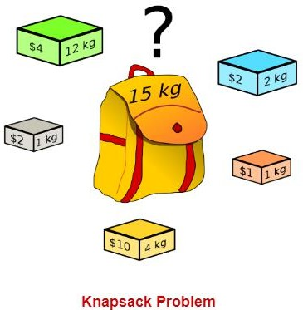

Knapsack Problem Variants
Knapsack problem has the following two variants-
- Fractional Knapsack Problem
- 0/1 Knapsack Problem

Fractional Knapsack Problem-
In Fractional Knapsack Problem,

  - As the name suggests, items are divisible here.
  - We can even put the fraction of any item into the knapsack if taking the complete item is not

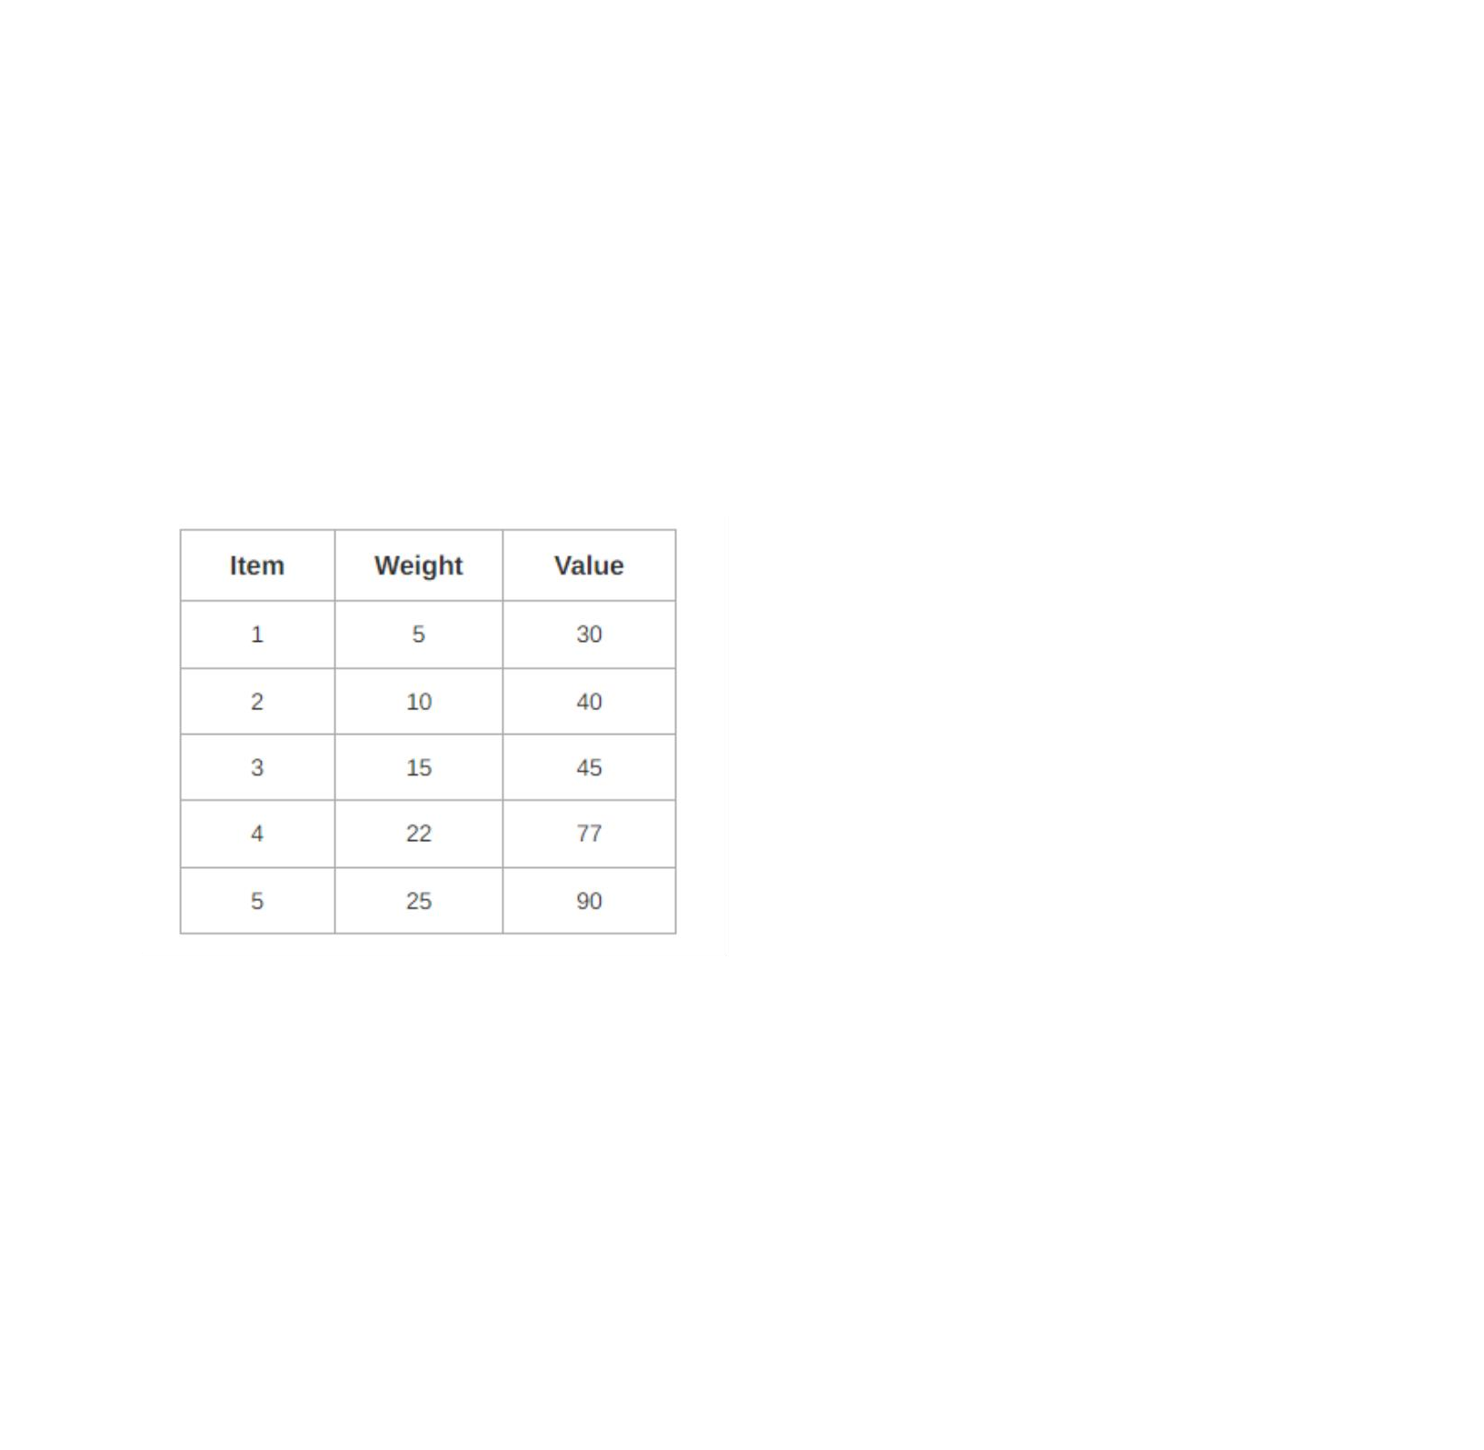
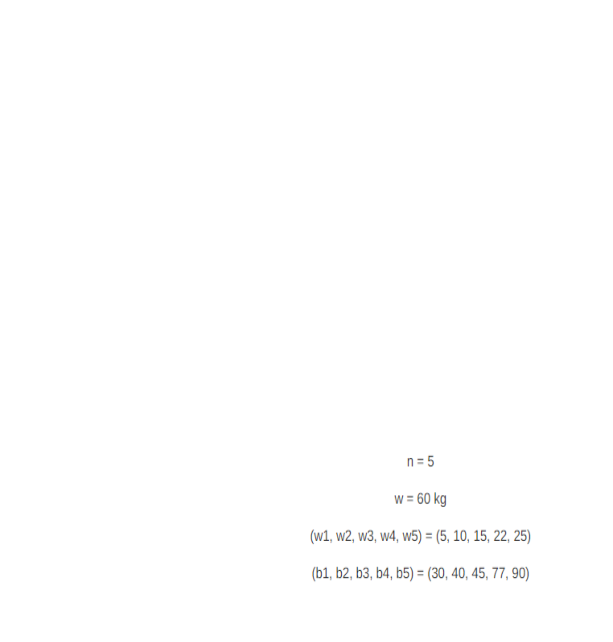
possible.
  - It is solved using the Greedy Method.

Fractional Knapsack Problem Using Greedy Method-
Fractional knapsack problem is solved using greedy method in the following steps-
Step-01:
For each item, compute its value / weight ratio.
Step-02:
Arrange all the items in decreasing order of their value / weight ratio.
Step-03:
Start putting the items into the knapsack beginning from the item with the highest ratio. Put as many items as you can into the knapsack.

Problem-
For the given set of items and knapsack capacity = 60 kg, find the optimal solution for the fractional knapsack problem making use of greedy approach.

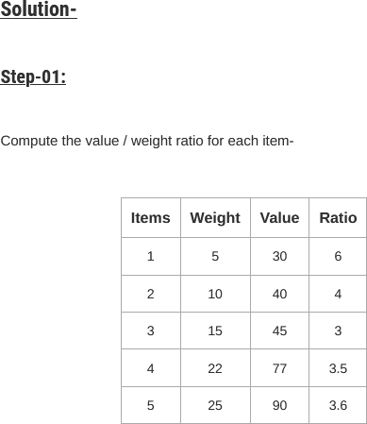

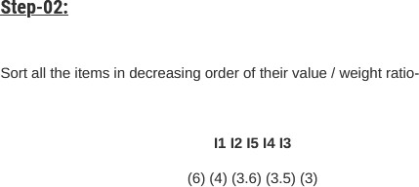

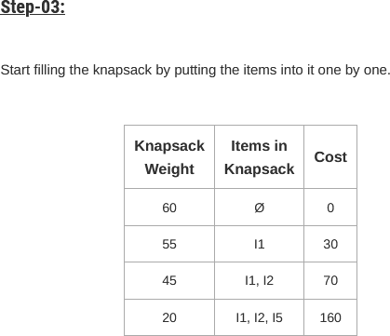

Now,

- Knapsack weight left to be filled is 20 kg but item-4 has a weight of 22 kg.
- Since in fractional knapsack problem, even the fraction of any item can be taken.
- So, knapsack will contain the following items-

< I1 , I2 , I5 , (20/22) I4 >

Total cost of the knapsack
= 160 + (20/22) x 77
= 160 + 70
= 230 units

Time Complexity-
- The main time taking step is the sorting of all items in decreasing order of their value / weight ratio.
- If the items are already arranged in the required order, then while loop takes O(n) time.
- The average time complexity of Quick Sort is O(nlogn).
- Therefore, total time taken including the sort is O(nlogn).

Conclusion-In this way we have explored Concept of Fractional Knapsack using greedy method

Assignment Question

- What is Greedy Approach?
- Explain concept of fractional knapsack
- Difference between Fractional and 0/1 Knapsack
- Solve one example based on Fractional knapsack(Other than Manual)

Reference link
- https://www.gatevidyalay.com/fractional-knapsack-problem-using-greedy-approach/

